Faculty Proforma for the GMC Budan Website

1. Name: Dr. Sucheta Yadav

..........................
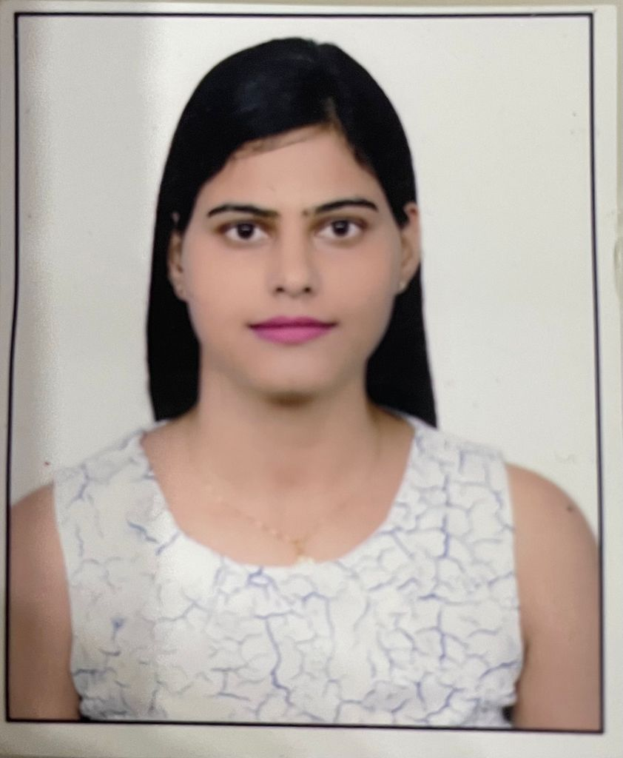

2. Qualification: MD Pathology

3. Fellowships:

4. Date of joining: 13/10/2021

5. Date of Birth: 10/07/1986, Gender: Female

6. Designation: Assistant Professor (Contractual)

7. Department: Immuno-hematology & Blood transfusion

8. Specialization: Pathology

9. Area of Interest: Histopathology & Cytopathology

10. OPD days: .......................NA..............................................................................................................

11. OPD Room No.: ......................N A ........................ .Timings: ....N A............

12. Super speciality clinic: ....NA....Room No / ward No. : ......NA..........

13. Super speciality clinic days.....................NA..........................Timings: ...............NA..................

14. Awards: .......................................................................................................................................

a.International

b.National

c.State level

d.District Level

15. Achievements:

a. Publications (Index/Peer reviewed): .............

Sl.  No. | Title of Article | Journal | Year/Month
1.  2. | Utility of C4D deposits in native renal diseases and relation with disease progression  Role of Endoscopic Retrograde Cholangio-Pancreatography Guided Brush Cytology in Evaluation of Malignant Biliary Tract Strictures: Experience of a Tertiary Care Teaching Centre in Northern India. | Indian Journal of Health Sciences and Biomedical Research (KLEU).  Journal of Clinical &amp; Diagnostic Research | 2019/January  2018/ December

b. Publications (Non indexed): ............................................................................

Sl.  No. | Title of Article | Journal | Year/Month

c. Books/Book Chapters: ...................................................................................

Sl.  No. | Author/s | Title | Publisher | Year of publication | Page No.

d. Invited Oral Presentations:...........................................................................................

Sl.  No. | Title | Title of conference/seminar | Year of publication | Publisher

e. Research Presentations (Oral): National................International............................

Sl.  No. | Title of the paper | Title of conference/ seminar volume | Year of publication | Publisher

f. Research Presentations (Poster): National................International...............................

Sl.  No. | Title of the paper | Title of conference/ seminar volume | Year of publication | Publisher

g.Others : …………………………………………………………………………………………………………………………….

16. Research Work : C4D deposits in native renal diseases and relation with disease progression
a. Research guidance : Awarded Submitted Ongoing
……………………. ……………………… …………………..
b. Ongoing Thesis : ……………………………………………………………………………………………….
SI No. | Title of the Project | Chief/Co-investigators | Date of Commencement | Expected date of completion
1
2
3
c.Other ongoing projects :
17. Life Memberships :
18. Grants received : ……… …………………………………………………………………………………
19. Other Corporate responsibilities
a.

20. Community Services :
21. Social Services :
22. Previous Appointments : ………
S.No. | Name of Post | From | To | Duration
2.
3.
4.
5.

23. Email :sucheta.kgmc09@gmail.com
24. Website : ………………………… …………………………………………………………………………………………………………………
25. Phone/Mobile No. : (RES)9310601867
26. Fax : ……………………………………………………………………………………………………………………………
27. Address for Communications :B95, DM road, civil lines, Badaun, 243601

