**Faculty Proforma for the GMC Budan Website**

1. Name: DR. Amit Kumar

..........................

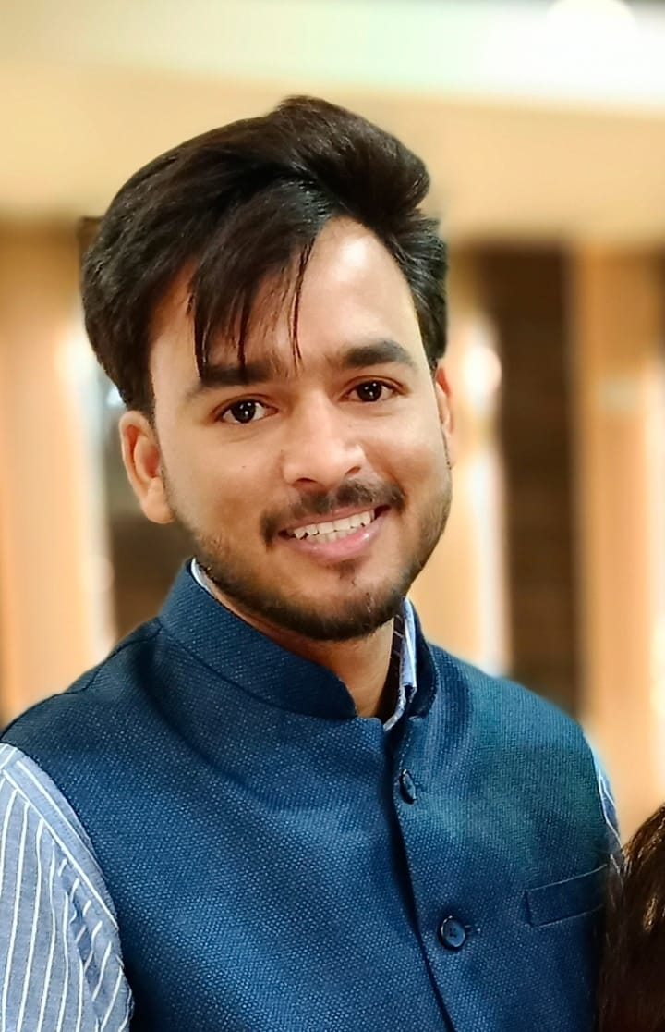

2. Qualification: M.Sc., Medical Pharmacology

3. Fellowships:

4. Date of joining: 12.04.2022

5. Date of Birth: 03.05.1990. Gender: Male

6. Designation: Assistant Professor

7. Department: Pharmacology

8. Specialization: Medical Pharmacology

9. Area of Interest: Teaching & Research

10. OPD days:.......................NA..............................................................................................................

11. OPD RoomNo.: ......................N A .........................Timings:....N A............

12. Super speciality clinic: ....NA....Room No / wardNo. : ......NA..........

13. Super speciality clinicdays.....................NA..........................Timings:...............NA..................

14. Awards:.......................................................................................................................................

a.International

b.National

c.Statelevel

d.DistrictLevel

15.Achievements:

a. Publications (Index/Peer reviewed):.............

|  |  |  |  |
| --- | --- | --- | --- |
| **Sl.**  **No.** | **Title of Article** | **Journal** | **Year/Month** |
| 1 | Singh S, Kumar P,Kuchhal A, **Kumar A**, et al. Comparative evaluation of Cost – Effectiveness and Medication Adherence Between Olanzepine and Iloperidone in Patients of Psychosis. | Int Arch BioMed and Clin Res | 2017 |
| 2 | **Kumar A**, Singh S, et al. Causative Agents and Antimicrobial Sensitivity Pattern Among Patient of Urinary Tract Infection in a tertiary Care Hospital of Western Uttar Pradesh. | Int Arch BioMed and Clin Res | 2016 |
| 3 | Salmani MF, **Kumar A.** Toxicity and Mechanism of action of Paracetamol. | International Journal of Scientific Research | 2016 |
| 4 | Devmurari D, Kamal CM, Singh SN, **Kumar A**. Ofloxacin and Nitrofurantoin sensitivity pattern in patients of Urinary Tract Infection (UTI) at a tertiary care teaching hospital**.** | Int Arch BioMed and Clin Res | 2015 |

b. Publications (Nonindexed):............................................................................

|  |  |  |  |
| --- | --- | --- | --- |
| **Sl.**  **No.** | **Title of Article** | **Journal** | **Year/Month** |
|  |  |  |  |

c. Books/Book Chapters:...................................................................................

|  |  |  |  |  |  |
| --- | --- | --- | --- | --- | --- |
| **Sl.**  **No.** | **Author/s** | **Title** | **Publisher** | **Year of publication** | **Page No.** |
|  |  |  |  |  |  |

d. Invited OralPresentations:...........................................................................................

|  |  |  |  |  |
| --- | --- | --- | --- | --- |
| **Sl.**  **No.** | **Title** | **Title of conference/seminar** | **Year of publication** | **Publisher** |
|  |  |  |  |  |

e. Research Presentations (Oral):National................International............................

|  |  |  |  |  |
| --- | --- | --- | --- | --- |
| **Sl.**  **No.** | **Title of the paper** | **Title of conference/seminar volume** | **Year of publication** | **Publisher** |
|  |  |  |  |  |

f. Research Presentations (Poster):National................International...............................

|  |  |  |  |  |
| --- | --- | --- | --- | --- |
| **Sl.**  **No.** | **Title of the paper** | **Title of conference/seminar volume** | **Year of publication** | **Publisher** |
|  |  |  |  |  |

**g.Others : …………………………………………………………………………………………………………………………….**

**16. Research Work : …………………………………………………………………………………………………**

**a. Research guidance : Awarded Submitted Ongoing**

**……………………. ……………………… …………………..**

**b. Ongoing Thesis :** ……………………………………………………………………………………………….

|  |  |  |  |  |
| --- | --- | --- | --- | --- |
| **SI No.** | **Title of the Project** | **Chief/Co-investigators** | **Date of Commencement** | **Expected date of completion** |
| 1 |  |  |  |  |
| 2 |  |  |  |  |
| 3 |  |  |  |  |

**c.Other ongoing projects :**

**17. Life Memberships :**

**18. Grants received : …………………………………………………………………………………………**

**19. Other Corporate responsibilities**

**a.**

**20. Community Services :**

**21. Social Services :**

**22. Previous Appointments : ………**

|  |  |  |  |  |
| --- | --- | --- | --- | --- |
| S.No. | Name of Post | From | To | Duration |
|  | **FHMC, Tundla** as **Tutor**.  **ASMC, Firozabad** as **Tutor** | **14-09-2015**  **06.11.2020** | **10-05-2019**  **11.04.2022** | 3 years 7months  1 year 3 months |
| 2. | **FHMC, Tundla** as **Assistant Professor** | **11-05-2019** | **02-03-2020** | 9 months |
| 3. | **ASMC, Firozabad** as **Assistant Professor** fro | **04-03-2020** | **05-11-2020** | 8 months |
| 4. | GMCBudaun as **Assistant Professor** | 12.04.2022 | till date. |  |
| 5. |  |  |  |  |

**23. Email : amitgautam.msc@gmail.com**

**24. Website : ………………………………………………**

**25. Phone/Mobile No. : (RES)8171752521**

**26. Fax : ……………………………………………………………………………………………………………………………**

**27. Address for Communications : Department of Pharmacology,**

**Government medical college, Budaun, U.P.**